**Deploying an Online Movie Watching Application on Cloud.**

DESCRIPTION

You are working in an online entertainment provider company. As you have knowledge of cloud computing, you are asked to deploy the company’s website on cloud.

Background of the problem statement:

You work for Binge Watch Online, an online entertainment provider company.

You have created a website for the company and used a public cloud to deploy the website. After deploying it on cloud, users are complaining about the reloading speed of the pages. The website is getting global traffic and static assets like pages that are served from a single server. You need to make sure that the traffic coming to the website from different parts of the world is load balanced at the DNS level.

You can use either Azure or AWS platforms to design the solution using IaaS OR PaaS.

Either if the below resources can be used , here we are using Azure Stack

* AWS: Route 53, S3 Bucket, CloudFront, EC2
* Azure: Azure App Service, CDN, DNS, Azure VM, Azure Traffic Manager

You have been asked to:

1. Suggest an appropriate solution so that your company can make use of the cloud while keeping the requirements mentioned above for your company in mind
2. Provide an approach to:

a. Govern all the resources being used for development, testing, and production of the company’s website

b. Keep a separate track of the billing life cycle and cost management of all the services being used for hosting the company’s website on Cloud

1. Upload all static content of your web site to cloud
2. Create a CDN endpoint and configure it to serve the static files you have uploaded
3. Use storage service and upload files for your teammates to share
4. Connect a Windows or Linux VM to the Storage service

Below is the overall architectural representation of the Project:

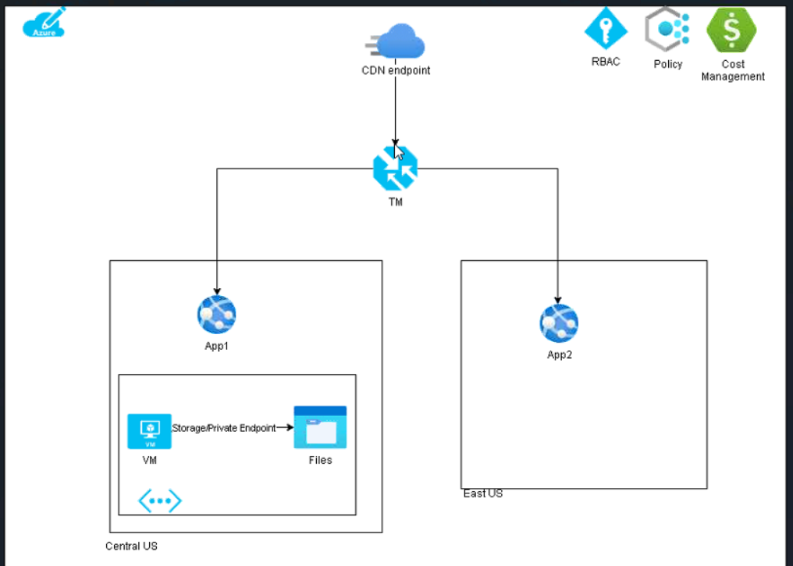

Follow the below steps to achieve the above architecture :

Login to Azure CLI

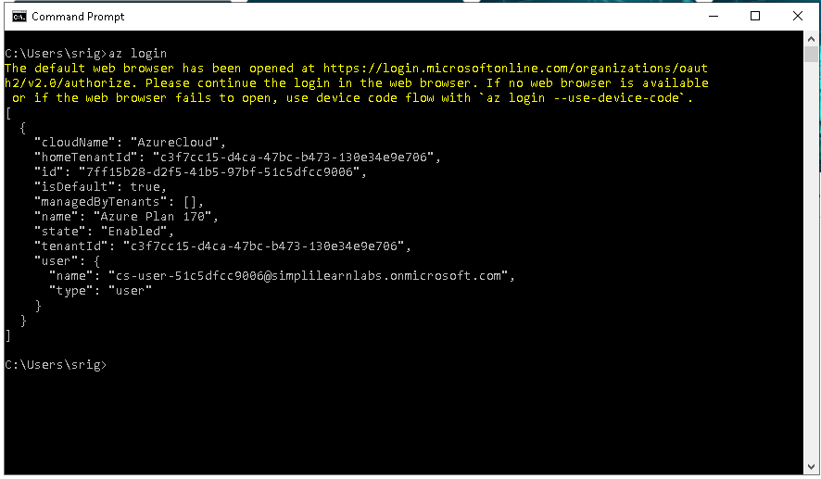

Create a resource group at CentralUS

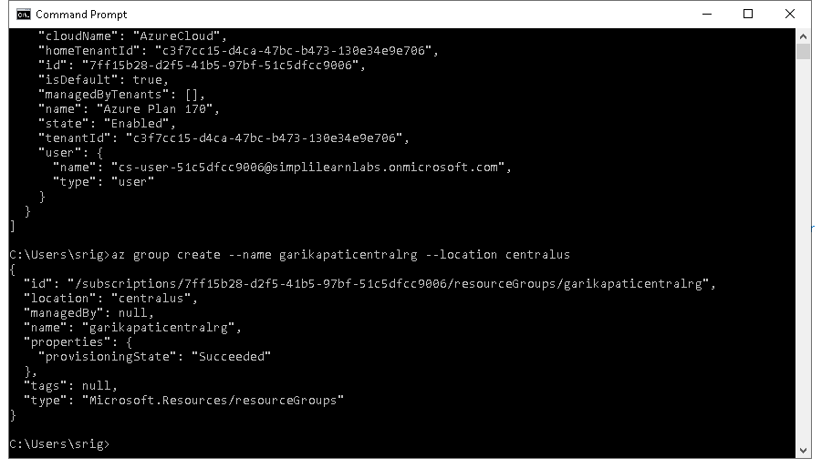

Create a resource group at Eastren US Zone

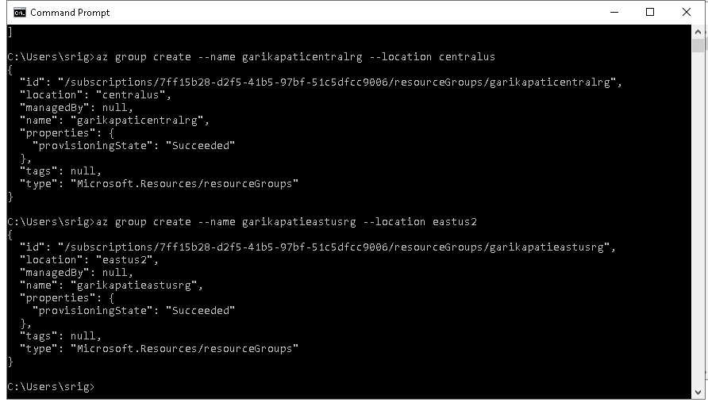

Deploy the webapps and app service plan by accessing the static files (Online_Movie_Registration_Form) location and performing the below command

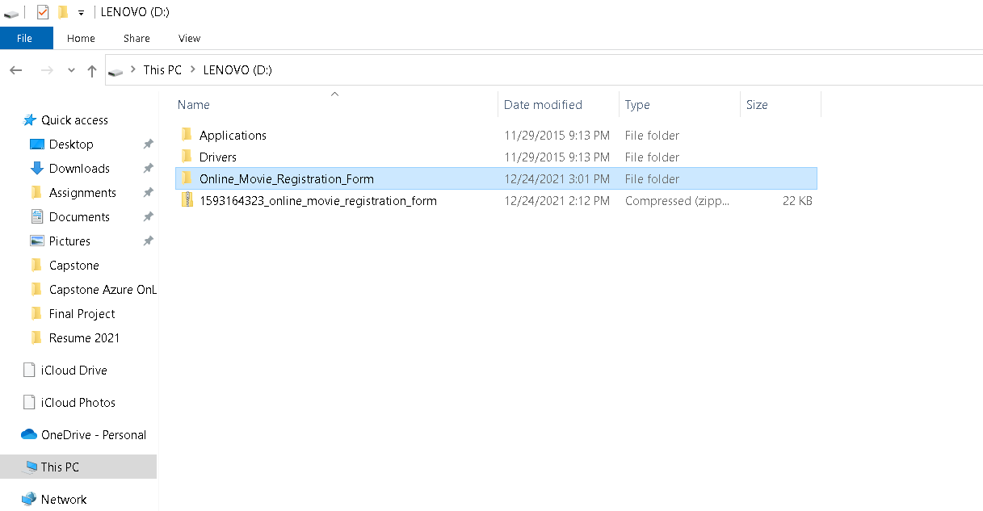

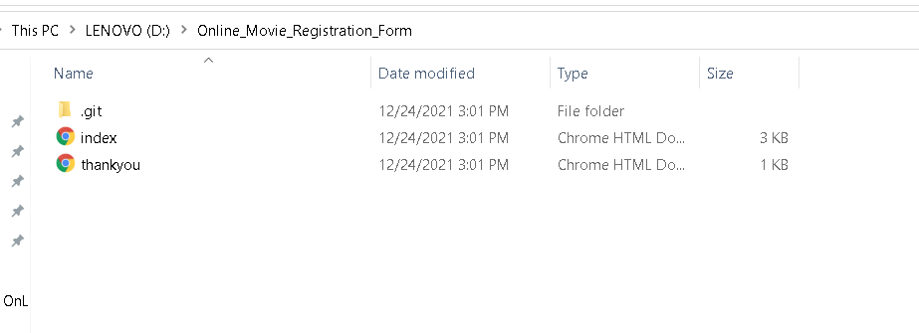

Perform the below command to deploy WebApps and App Service Plan

az webapp up --name srikanthapp1 --location centralus --resource-group garikapaticentralrg --plan srikanthapp1plan --sku S1 –html

The above command includes name of the web app, location, resource group in which the webapp added, name of the plan of the webapp , Sku of the webapp and flag that indicates that it is static web app deployment

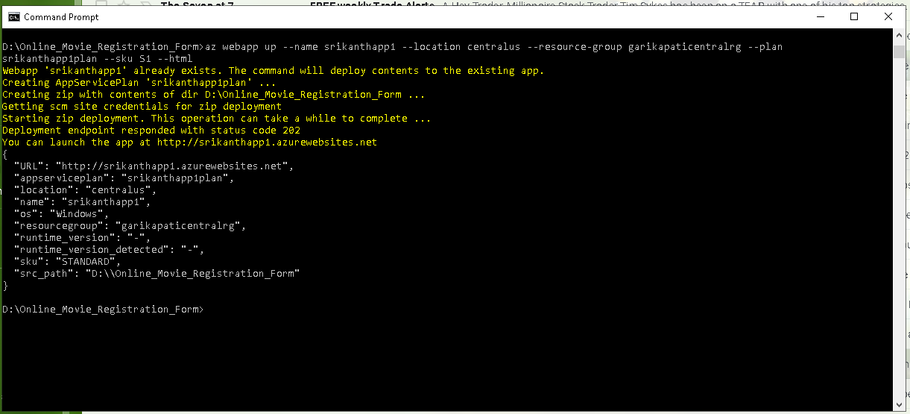

Perform same steps as above to create second webapp in the second resource group ( eastus2 )

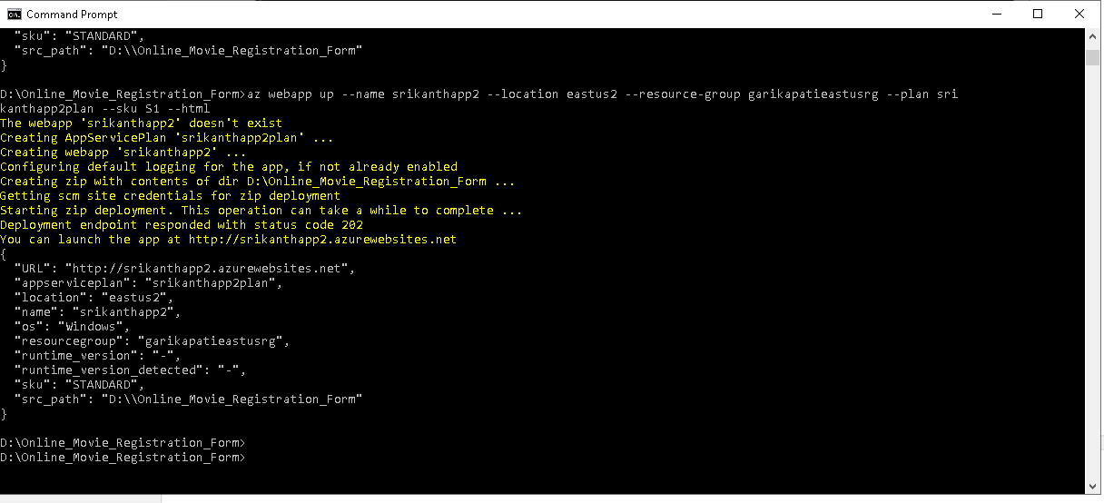

Verify resource groups are created at Azure Portal

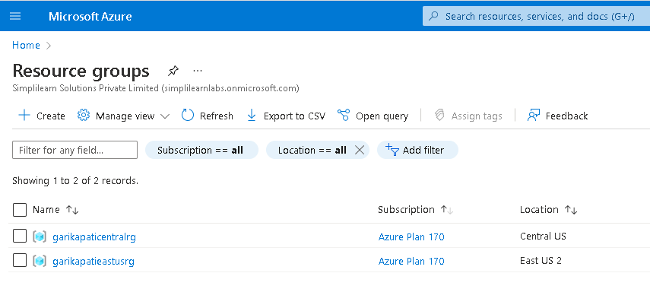

Verify App Service and App Service Plan are created in Azure Portal

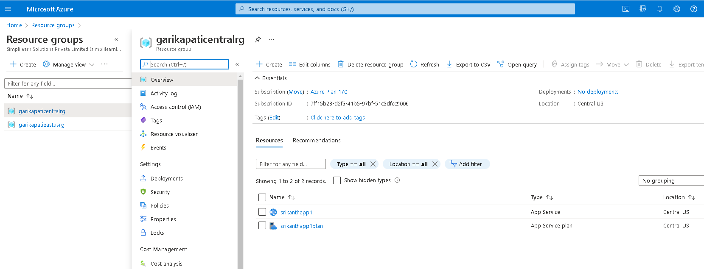

Make sure the app is launched by copying the url from the cmd prompt and searching at browser

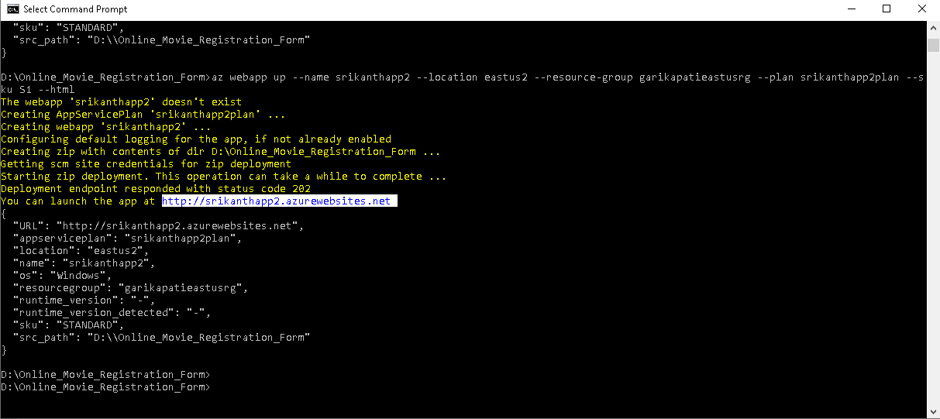

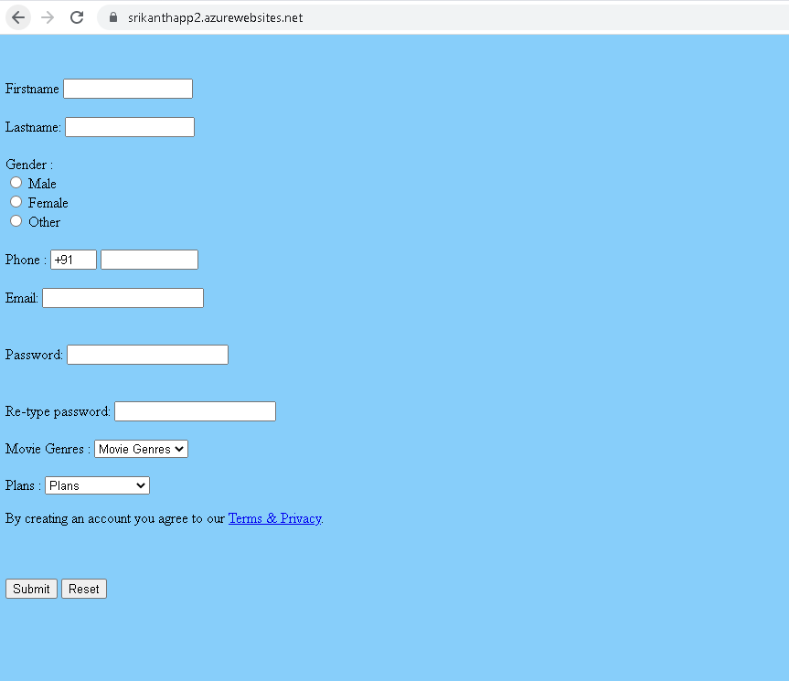

We can see the app is launched in the above picture

**Note: We can we use blob storage instead of App service , advantage with app service is it has compute engine in the background along with storage service whereas Blob service will only have storage service ( no compute engines )**

Create a Traffic Manager Profile

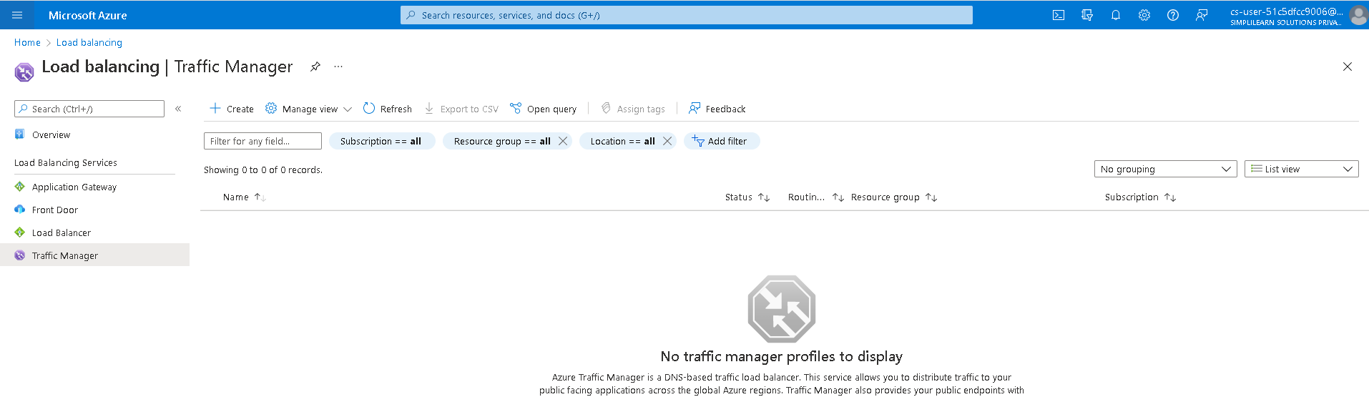

Traffic Manager can be created at any resource group as it is global service and stores only metadata

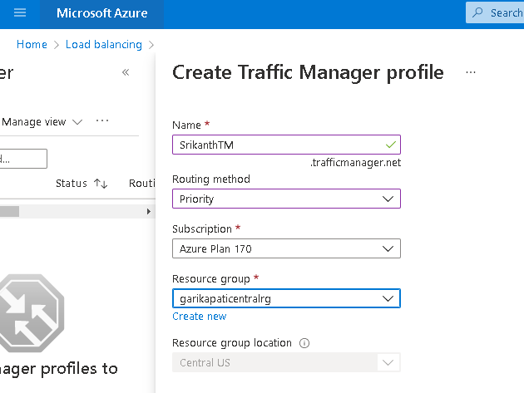

Create Endpoints that points to WebApps

Create Endpoint for appservice1 ( here Srikanthapp1 )

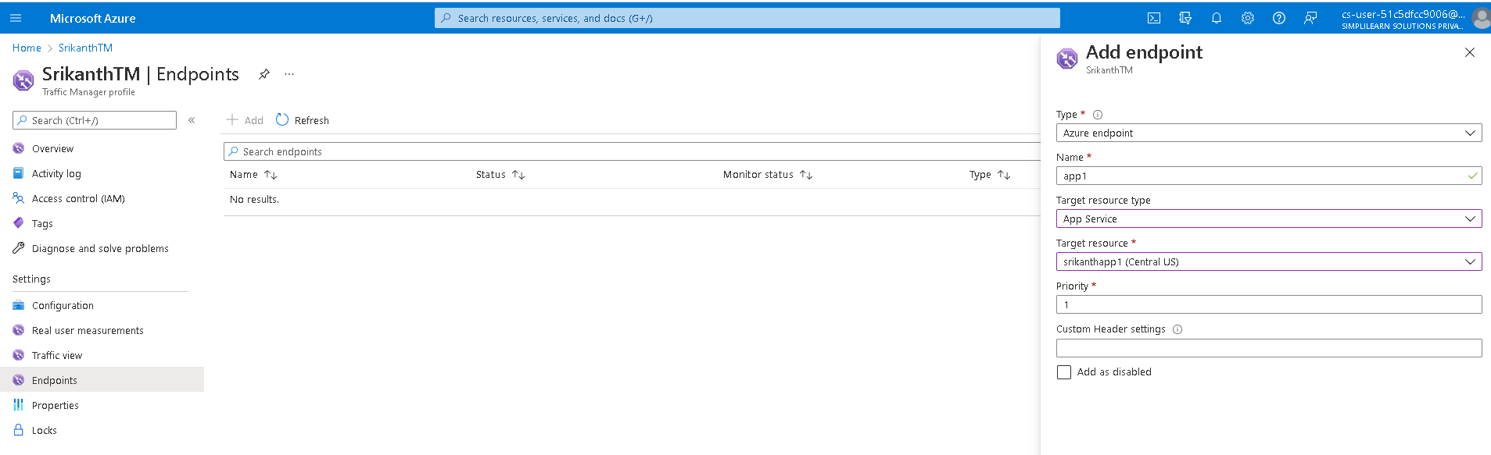

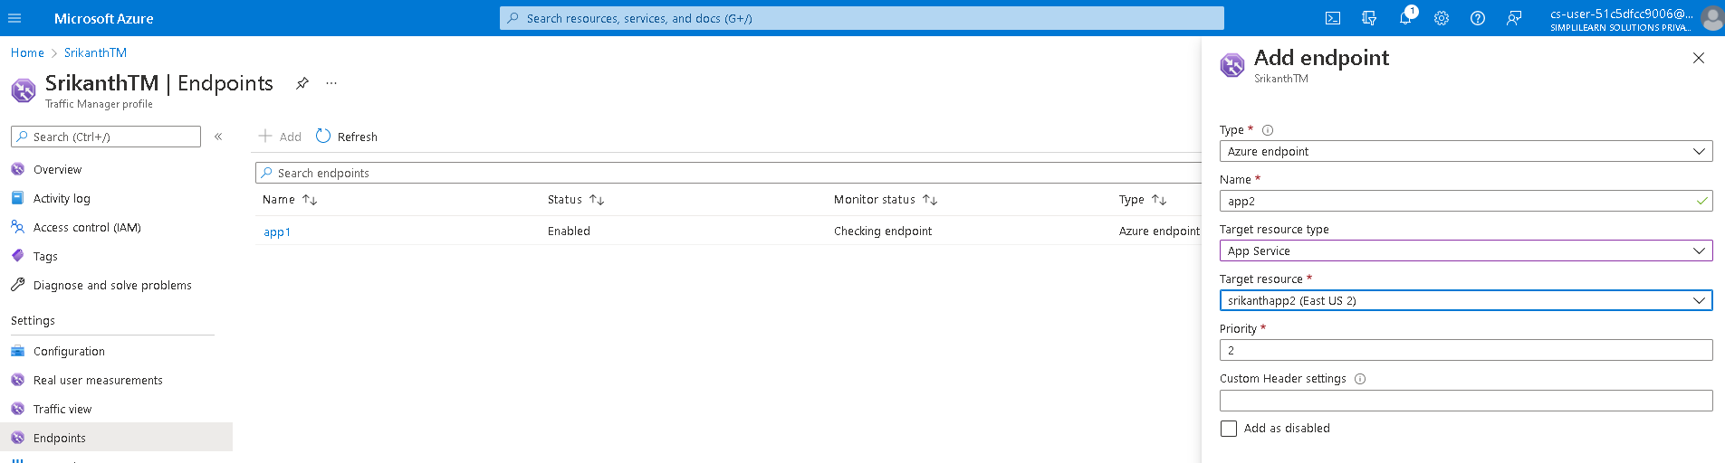

Both endpoints are created as below

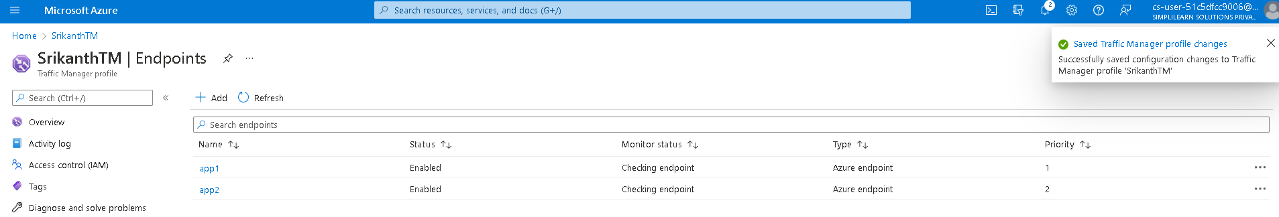

Check if the Traffic Manager is hitting the website, copy TM url and paste the url at the browser

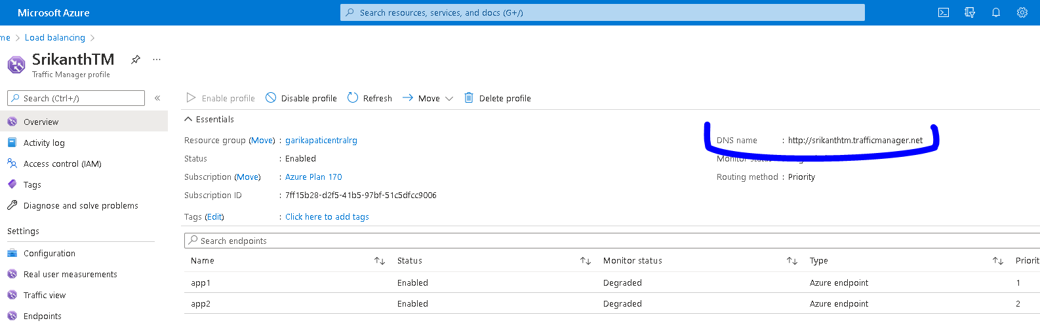

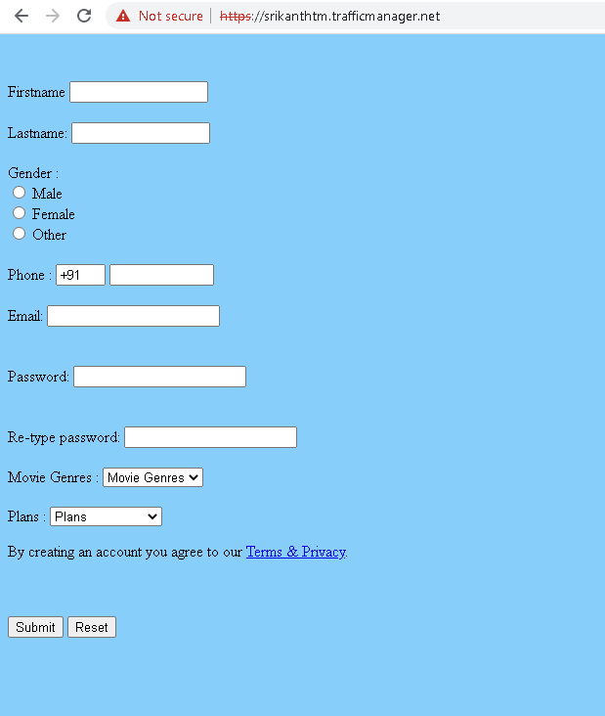

Above picture demonstrates that the Traffic Manager successfully hits the website

Create A CDN Profile

As CDN profile is global service we can create it under any resource group

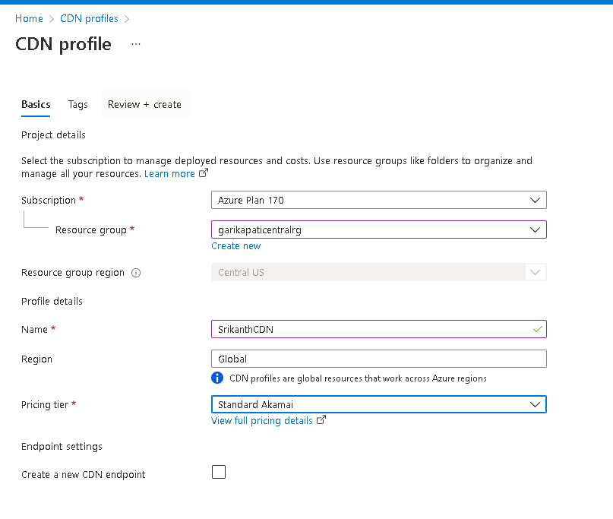

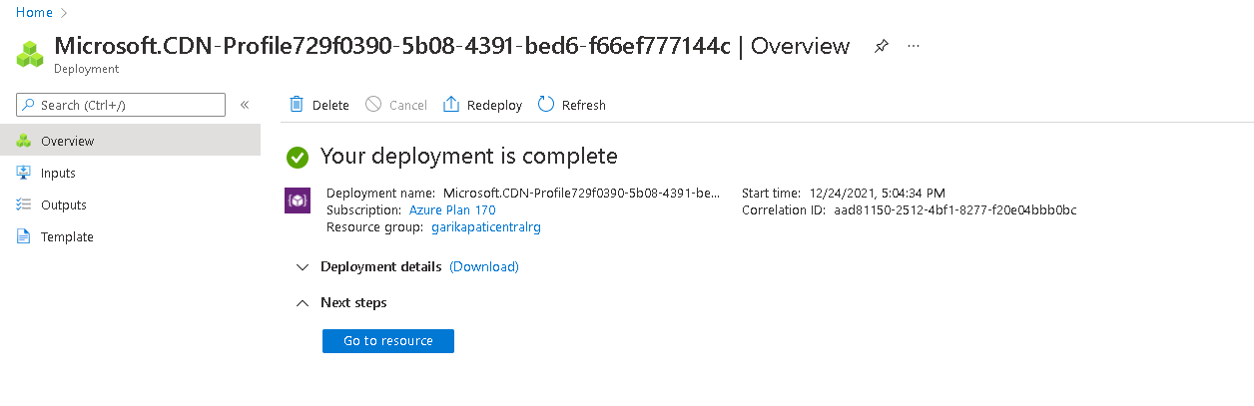

Once profile is created, create an endpoint

Add TrafficManager url as OriginHostName

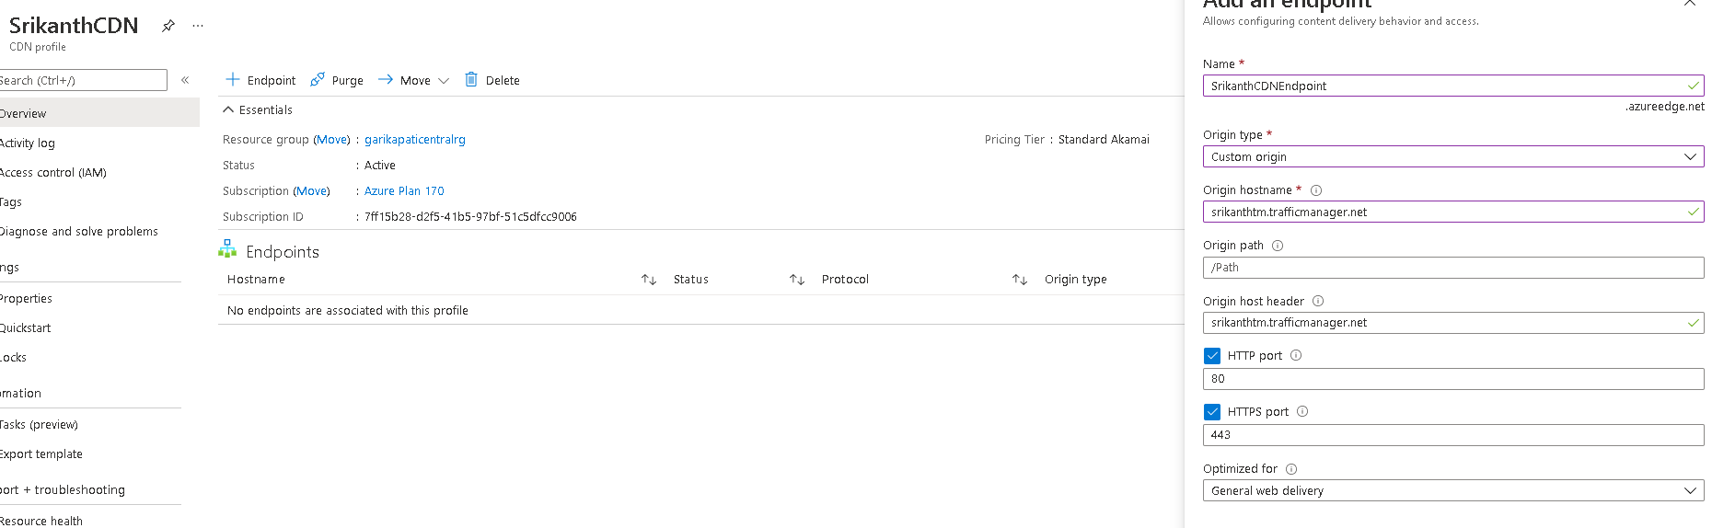

Let’s test something here.

As we didn’t create SSL certificate for the CDN profile, if we search CDN url with HTTPS we are expecting an error as below

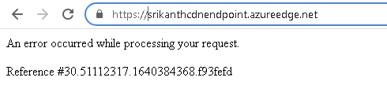

**If we are seeing any error with reference number starting with 30 that is related to SSL certification**

Now let’s test the CDN url with http instead of https

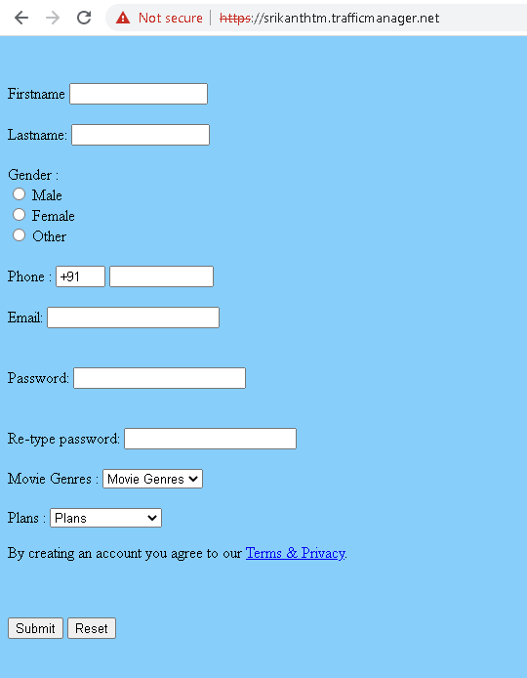

We can see we will be able to access the website with http as above

Next , Create a Virtual Machine

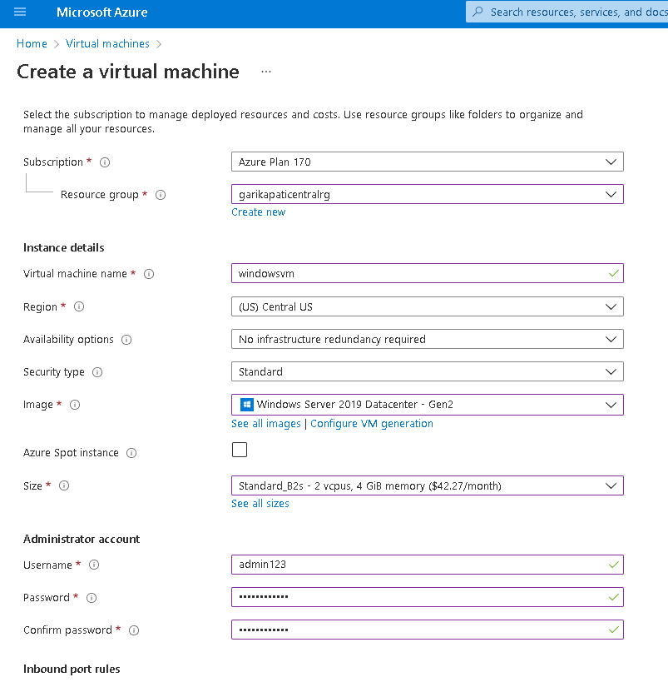

Select standard HDD as Disk Type

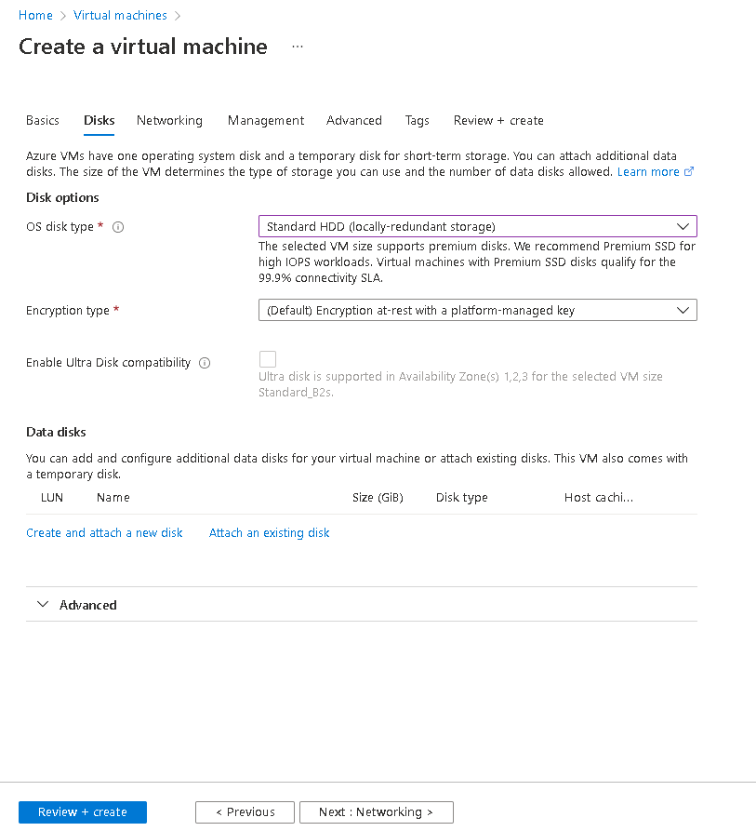

Select the vnet that’s created in the subnet

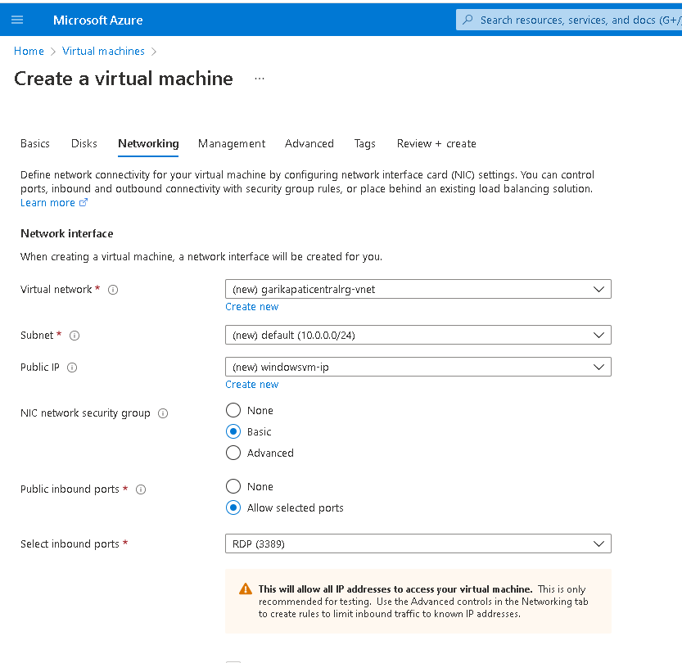

Create Storage Account

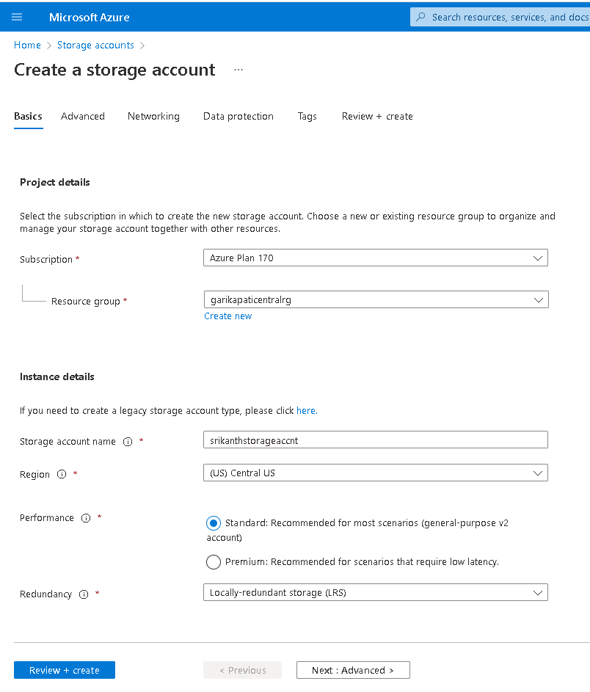

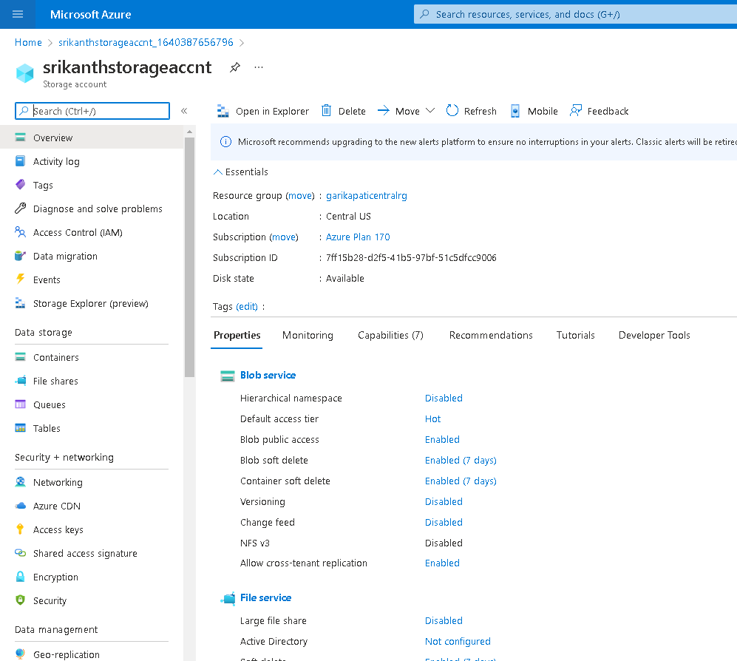

By default any service in the storage account is public, we need to point to private endpoint when we do file share

To achieve the above the requirement follow the below steps

* 1. Go to networking
  2. Select firewall and virtual networks
  3. Select allow access as Selected networks
  4. Add existing virtual network
  5. Select Subnet and enable storage end point

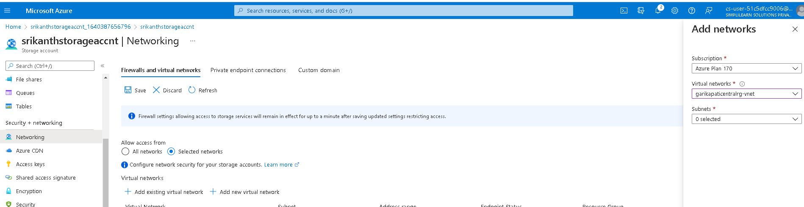

Now the storage is accessible only in the Virtual network

Create a file share

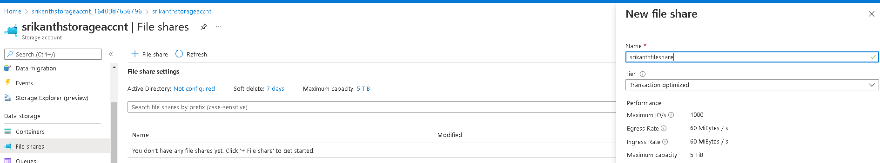

Mount the file share with virtual machine

Now let’s try to access file share at the portal

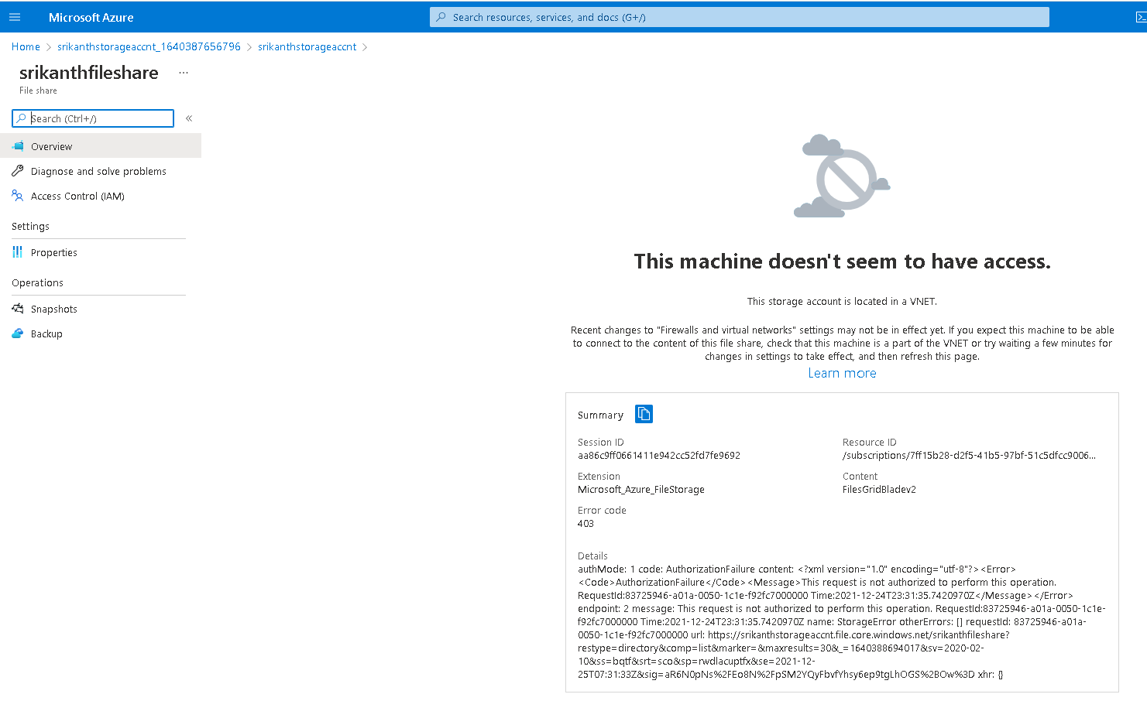

We will see the above error, as we just made the file share private to the virtual network

**The only way to access the fileshare is to login to virtual machine and access the Azure portal inside the virtual machine**

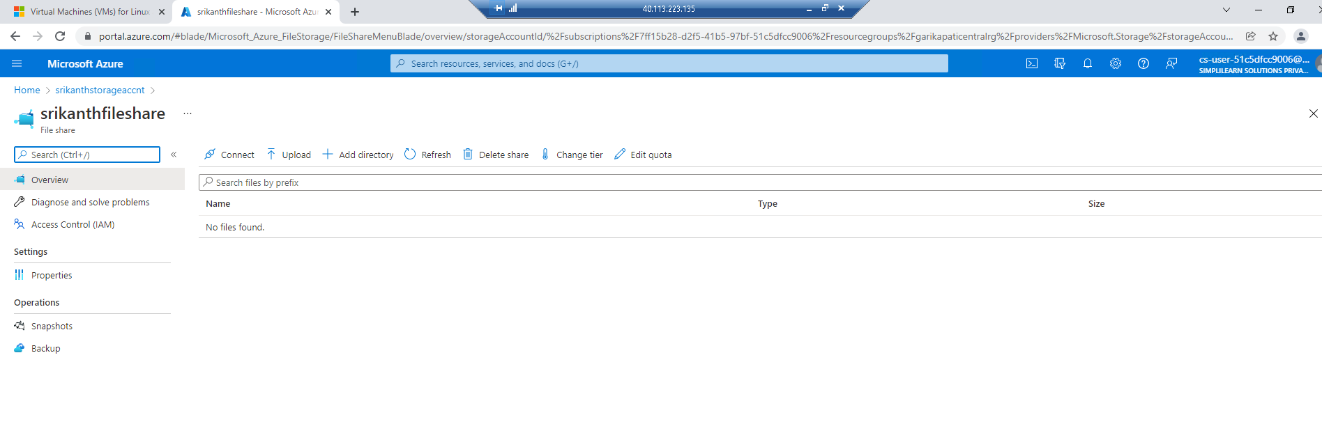

Now we can see we are able to access the file share from inside the virtual machine

Connect to fileshare service

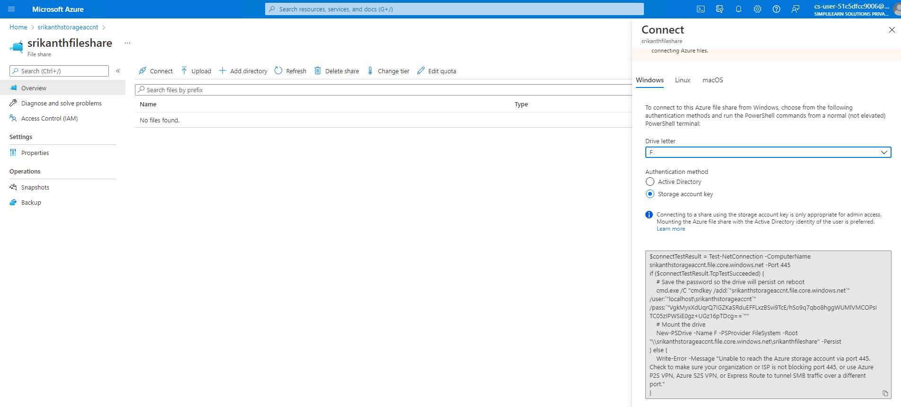

Copy the Shell command to mount the fileshare in my file explorer

$connectTestResult = Test-NetConnection -ComputerName srikanthstorageaccnt.file.core.windows.net -Port 445

if ($connectTestResult.TcpTestSucceeded) {

# Save the password so the drive will persist on reboot

cmd.exe /C "cmdkey /add:`"srikanthstorageaccnt.file.core.windows.net`" /user:`"localhost\srikanthstorageaccnt`" /pass:`"VgkMyxXdUqrQ7IGZKaSRduEFFLxzBSvi9TcE/hSo9q7qbo8hggWUMlVMCOPsITC05zIPWSiE0gz+UGz16pTDcg==`""

# Mount the drive

New-PSDrive -Name F -PSProvider FileSystem -Root "\\srikanthstorageaccnt.file.core.windows.net\srikanthfileshare" -Persist

} else {

Write-Error -Message "Unable to reach the Azure storage account via port 445. Check to make sure your organization or ISP is not blocking port 445, or use Azure P2S VPN, Azure S2S VPN, or Express Route to tunnel SMB traffic over a different port."

}

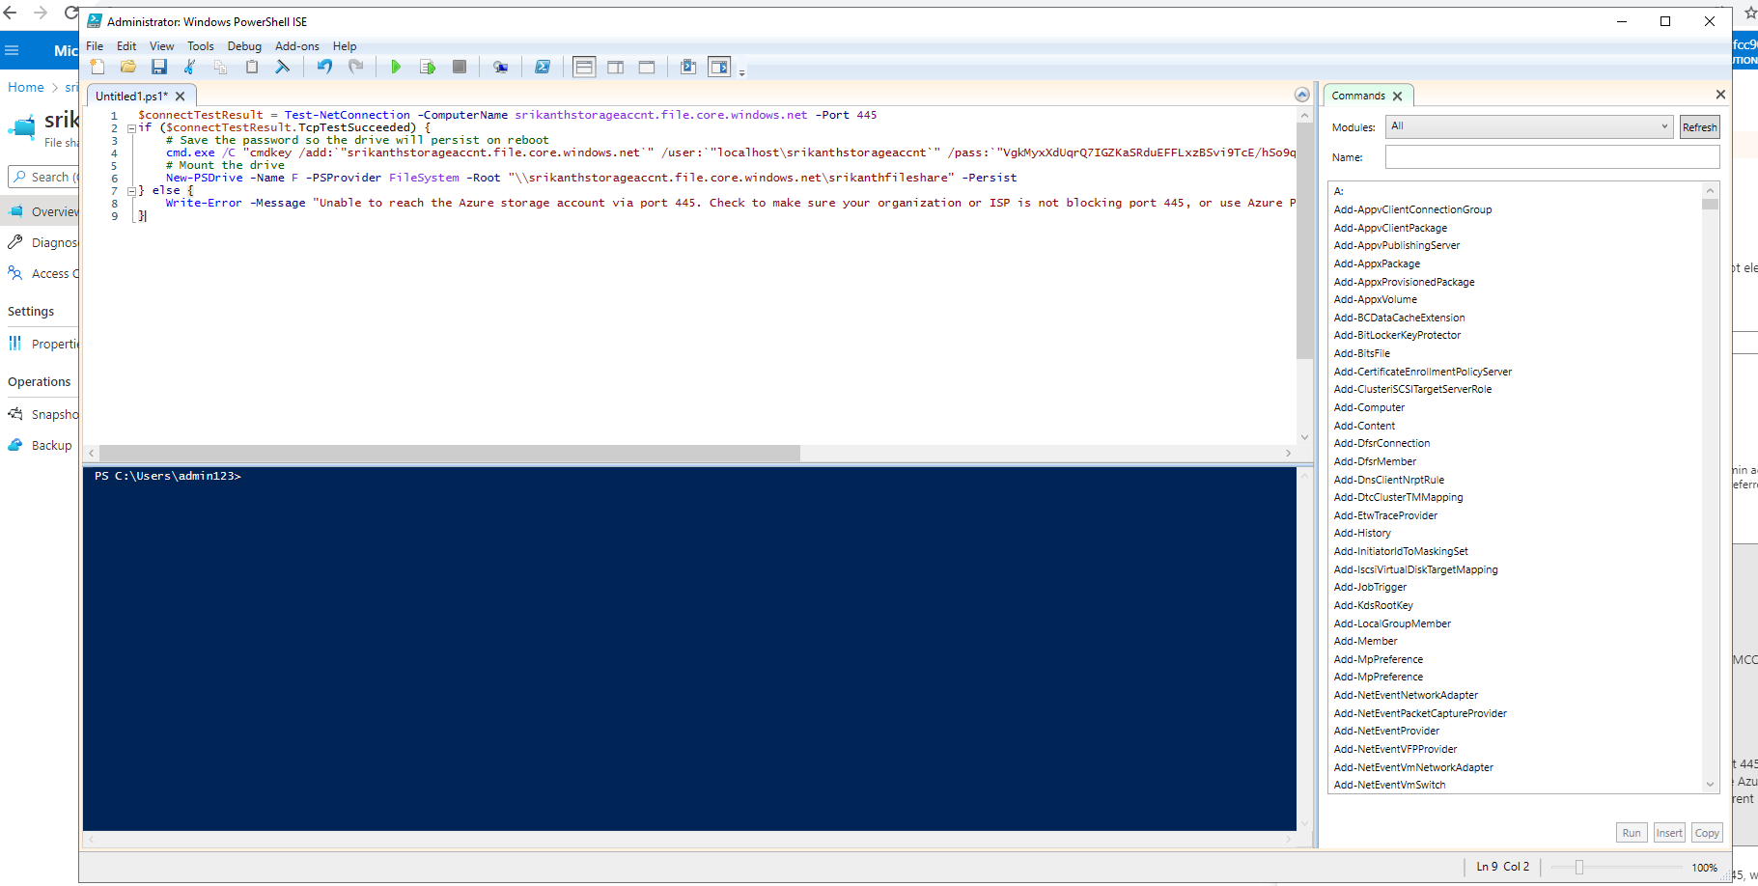

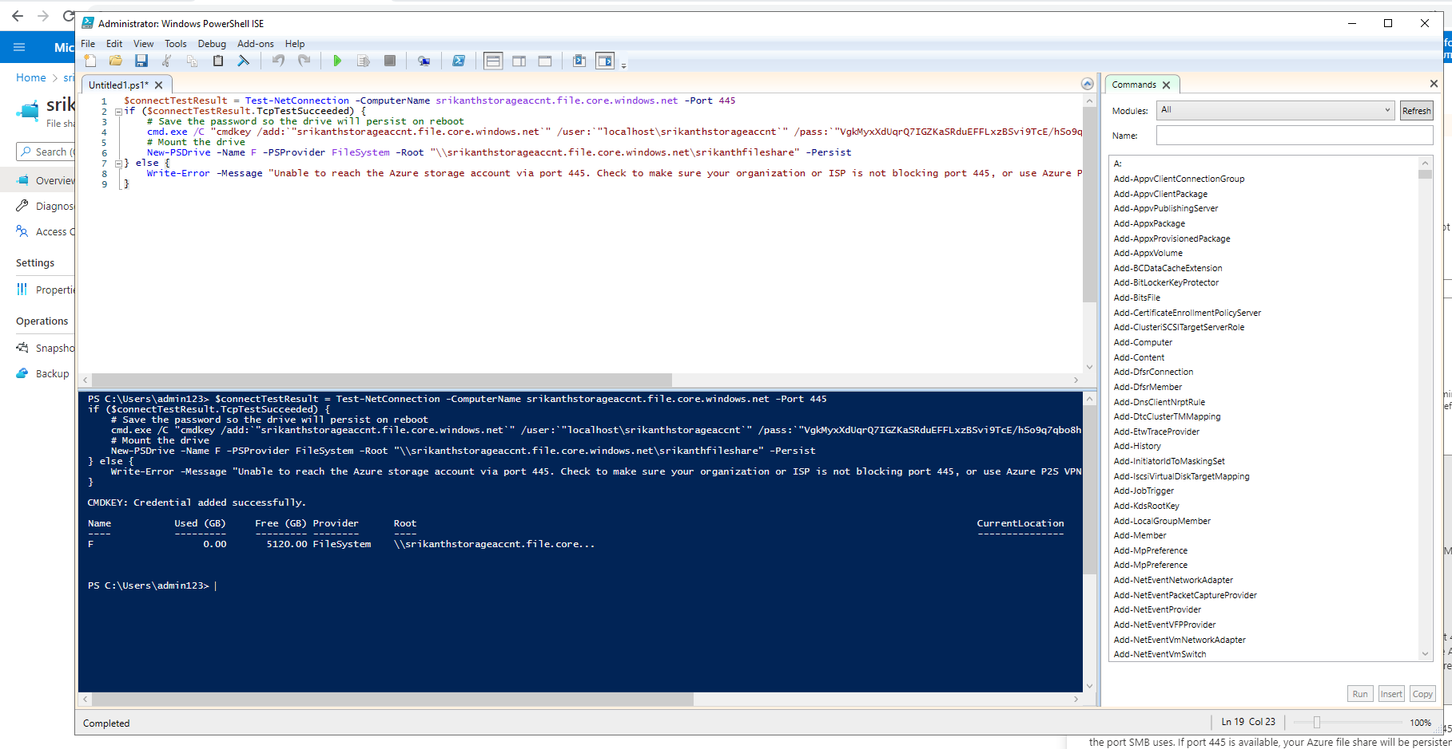

Verify if the fileshare exists in the file explorer windows

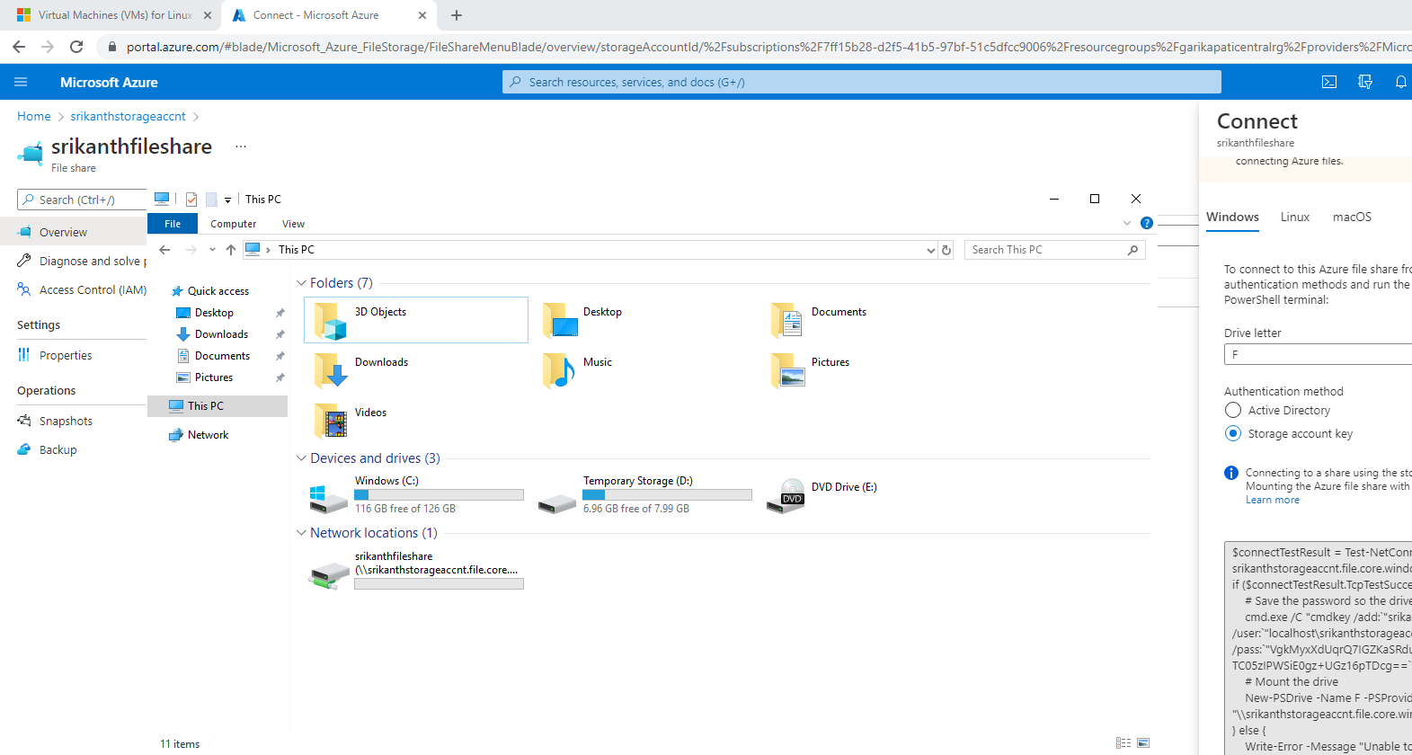

Verify if the file share connectivity is working

Fileshare is empty at portal

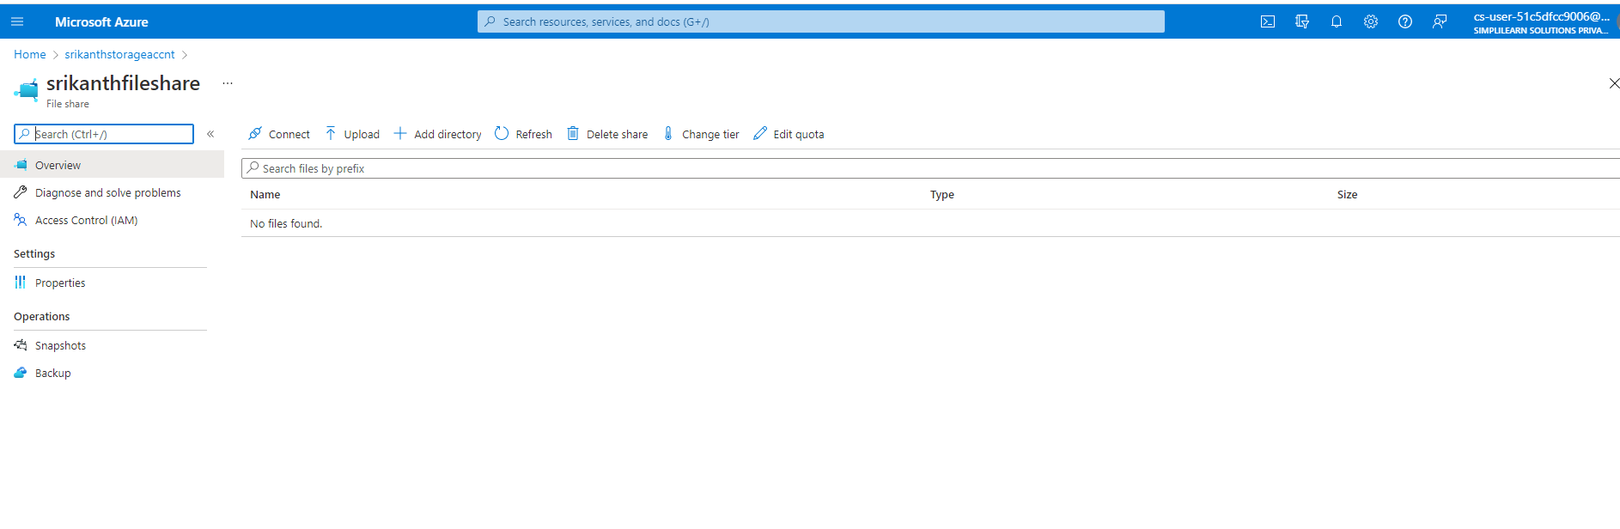

Let’s add some files at explorer and see if they reflect at portal

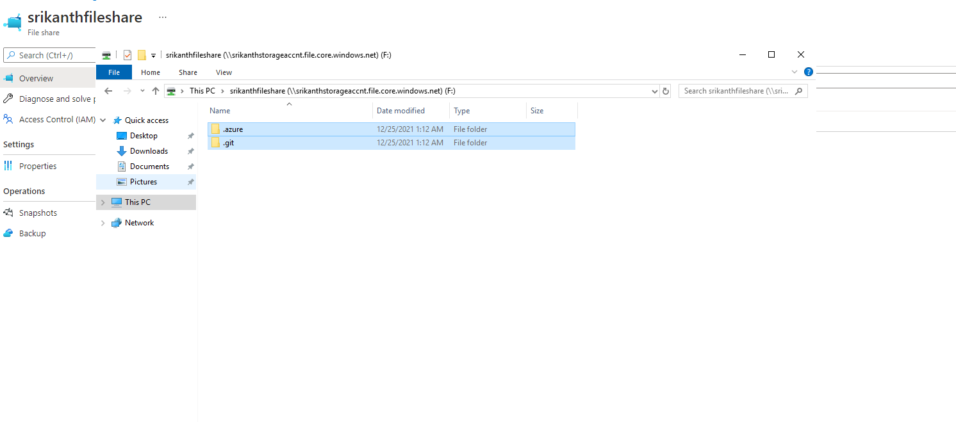

Files have been added at the explorer

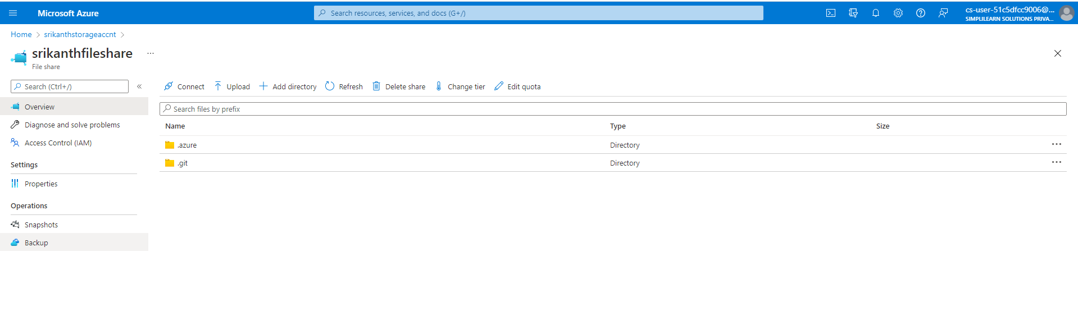

Added files are reflected at the portal